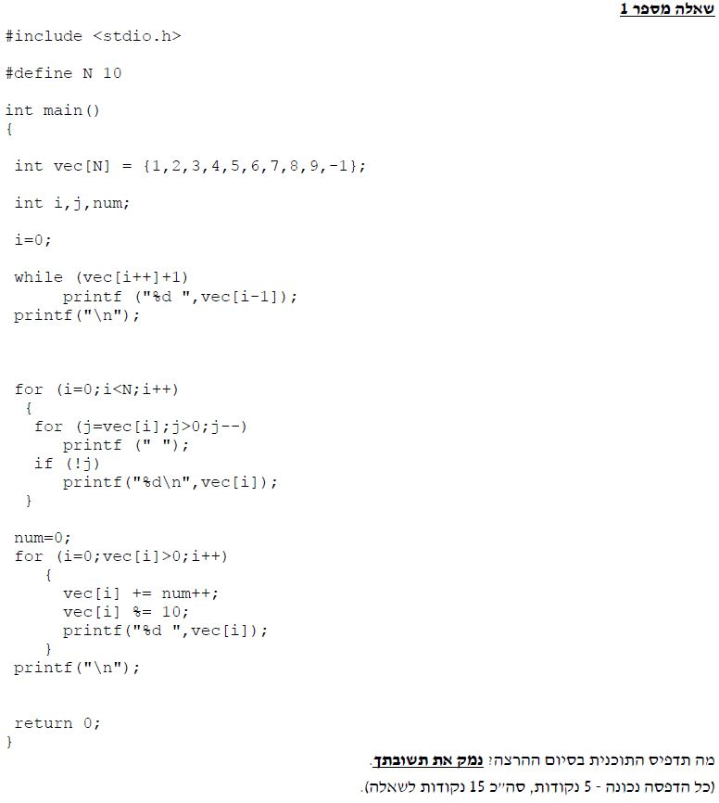

#include <stdio.h>

#define N 10

// Answer 1 Mahat Summer 2018 B

// Show what the program does:

int main()

{

int vec[N] = { 1,2,3,4,5,6,7,8,9,-1 }; // the -1 is not in use!

int i, j, num;

i = 0;

while (vec[i++] + 1) //i++ is after the first time.

printf("%d ", vec[i - 1]);

printf("\n");

for (i = 0; i < N; i++)

{

for (j = vec[i]; j > 0; j--)// j prints " " according to length of num.

printf(" ");

if (!j) // when j is 0

printf("%d\n", vec[i]); // print numbers 1-9.

}

num = 0;

for (i = 0; vec[i] > 0; i++) // goes on 1-9 (not -1)

{

vec[i] += num++; // num++ is after first time!

vec[i] %= 10; // for the bigger numbers - we take only achadot

printf("%d ", vec[i]); // print 1,3,5,7,9,1,3,5,7

}

printf("\n");

getchar();

return 0;

}

